PROJECT REPORT
Phase-I
On
Sign Matching through open CV and Pen Tracking by Machine Learning
Submitted to Rajasthan Technical University
in partial fulfillment of the requirement for the award of the degree of
B.TECH.
in
COMPUTER ENGINEERING
Submitted By
Ashutosh Kumawat (PIET17CS022)
Anushka Mangal(PIET17CS013)
Gagan Agarwal(PIET17CS038 )
Under the Guidance of
Mr. Deepak Moud
at
POORNIMA GROUP OF INSTITUTIONS
JAIPUR
Rajasthan Technical University, KOTA
NOVEMBER, 2020

CERTIFICATE
This is to be certified that the project entitled “Sign Matching through open CV and Pen Tracking by Machine Learning” has been submitted for the Bachelor of Computer Science and Engineering, Poornima Institute of Engineering & Technology, Jaipur during the academic year 2020-2021 is a bonafide piece of project work carried out by “ Ashutosh Kumawat, Anushka Mangal & Gagan Agarwat” towards the partial fulfillment for the award of the Degree (B.Tech.) under the guidance of “Mr. Deepak Moud” and supervision and no part of thereof has been submitted by them for any degree or diploma.

Project Guide Project Coordinator Mr. Deepak Moud
Mr./Mrs./Dr. Prof. (Dr.) Rekha Jain H.O.D CSE
(Designation) Professor

CANDIDATE’S DECLARATION

We, Ashutosh Kumawat (PIET17CS022), Anushka Mangal(PIET17CS013) & Gagan Agarwal(PIET17CS038) B.Tech (Semester- VII) of “Poornima Group of Institutions, Jaipur” hereby declare that the Project Report entitled “Sign Matching through open CV and Pen Tracking by Machine Learning” is an original work and data provided in the study is authentic to the best of our knowledge. This report has not been submitted to any other Institute for the award of any other degree.

Ashutosh kumawat | Anushka Mangal | Gagan Agarwal
(PIET17CS022) | (PIET17CS013) | (PIET17CS038)

Place:
Date:
ACKNOWLEDGEMENT
It is our pleasure to be indebted to various people, who directly or indirectly contributed in the development of this work and who influenced our thinking, behavior and acts during the course of study.
We express our sincere gratitude to Dr. Dinesh Goyal, Director, PIET for providing us an opportunity to undergo this Major Project as the part of the curriculum.
We are thankful to Mr. Deepak Moud, HOD, CS for his support, cooperation, and motivation provided to us during the training for constant inspiration, presence and blessings.
We are thankful to Mr/Mrs./Dr. Mr. Deepak Moud for his/her support, cooperation, and motivation provided to us during the training for constant inspiration, presence and blessings.
We also extend our sincere appreciation to Prof. (Dr.) Pooja Sharma who provided her valuable suggestions and precious time in accomplishing our Project report.
Lastly, we would like to thank the almighty and our parents for their moral support and friends with whom we shared our day-to-day experience and received lots of suggestions that improved our quality of work.

Ashutosh kumawat | Anushka Mangal | Gagan Agarwal
(PIET17CS022) | (PIET17CS013) | (PIET17CS038)

TABLE OF CONTENTS

CHAPTER NO. | TOPICS | PAGE NO.
 | TITLE PAGE | I
 | CERTIFICATE | II
 | CANDIDATE’S DECLARATION | III
 | ACKNOWLEDGEMENT | IV
 | TABLE OF CONTENTS | V
 | LIST OF FIGURE | VI
 | ABSTRACT | VII
1 | INTRODUCTION TO PROJECT | 1
Project Aim and Objective
Problem Statement
Background of the Project (Literature Survey)
Software Requirements
Hardware Requirements

2 | PRODUCT BACKLOG
- Product Backlog
- Sprint Backlog-1
- Sprint Backlog-2

3 | TECHNOLOGY APPLIED AND PROJECT MANAGEMENT
Technology Applied in the Project.
Project management- Agile
PO and Their Relevance to project
4 | PROJECT IMPLEMENTATION
Sprint Backlog-1
Sprint Backlog-2

5 | CONCLUSION
Conclusion
Future Scope

6 | ANNEXURES
 | References
LIST OF FIGURES

LIST OF FIGURES

S. NO. | FIGURE | PAGE NO.
1. | Product Backlog | 11
2. | Spring Backlog-1 | 12
3. | Burn Down Chart-1 | 13
4. | Spring Backlog-2 | 14
5. | Burn Down Chart-2 | 15

ABSTRACT

KEYWORDS: Machine learning, Deep Learning, Pen Tracking

Sign Matching through open CV and Pen Tracking by Machine Learning is the process of using machine-learning methods to validate the authenticity of an individual's signature. Aim of this project is to design an algorithm, which can distinguish between genuine and forged signatures using writer independent features, and to develop a system using this algorithm which can be used to verify signatures in organizations like in banks on cheques. We intend to build a complete end-to-end software system which can be used to take signature of the person without physical interaction using camera, perform signature verification, and display the results. For this purpose, various deep learning techniques were developed and tested on standard datasets for signature authentication, as well as on a dataset collected by ourselves.

CHAPTER 1
INTRODUCTION TO PROJECT

Project Aim and Objective:
Signature verification is a technique used by banks, intelligence agencies and high-profile institutions to validate the identity of an individual. Signature verification is often used to compare signatures in bank offices and other branch capture. An image of a signature or a direct signature is fed into the signature verification software and compared to the signature image on file. In today’s scenario private or public sector, organizations are using signatures to authenticate a person. This process is offline, there is more chances to authenticate a forged signature as genuine, and this process is time taking too and taking human resources. We are developing a solution for this by using machine-learning methods to validate the authenticity of an individual's signature. Aim of this project is to design an algorithm, which can distinguish between genuine and forged signatures using writer independent features, and to develop a system using this algorithm which can be used to verify signatures in organizations like in banks oncheques. We intend to build a complete end-to-end software system which can be used to take signature of the person without physical interaction using camera, perform signature verification, and display the results.

Problem Statement:
Today almost in every organizations whether it is private or public, signatures are used to check authenticity of that person. This process is done manually which consumes human resources. There is always chances of taking a forged signature as genuine. This takes time too. So the current process is bad in each perspective because it is consuming more time, consuming more human resources. After all this, the accuracy is also less.

Background of the Project (Literature Survey)
Signature verification is a type of software that compares signatures and checks for authenticity. This saves time and energy and helps to prevent human error during the signature process and lowers chances of fraud in the process of authentication. The software generates a confidence score against the signature to be verified. Too low of a confidence score means the signature is most likely a forgery.
Signature verification software has now become lightweight, fast, flexible and more reliable with multiple options for storage, multiple signatures against one ID and a huge database. It can automatically search for a signature within an image or file. Following are some research papers used for the reference:
- Hafemann, Luiz G., Robert Sabourin, and Luiz S. Oliveira. "Learning Features for Offline Handwritten Signature Verification using Deep Convolutional Neural Networks" http://dx.doi.org/10.1016/j.patcog.2017.05.012 (preprint).
- .Hafemann, Luiz G., Robert Sabourin, and Luiz S. Oliveira. "Fixed-sized representation learning from Offline Handwritten Signatures of different sizes" https://doi.org/10.1007/s10032-018-0301-6 (preprint).

Software Requirements
- We need Python 3 installed on the system on which we are going to use the software. We need following packages installed to run the software:
numpy
cv2
deque
math
alexnet
cocomo mode

CHAPTER 2
PRODUCT BACKLOG

- PRODUCT Backlog
The flow of project is converted into the form of product backlog to make the process easier into divided tasks and estimated time. The project is divided into 2 phases.

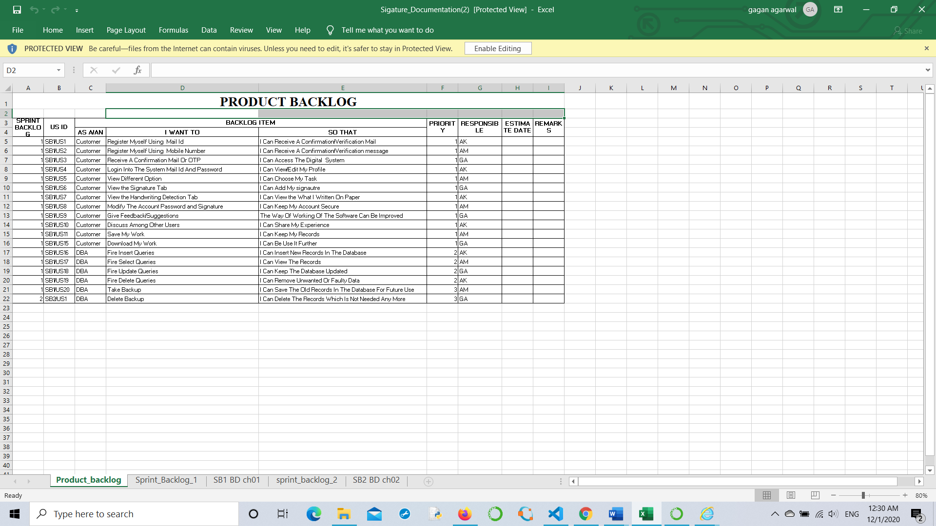
Fig1:- PRODUCT Backlog

- Sprint Backlog-1
In this phase all the preprocessing for the models and learning phase.

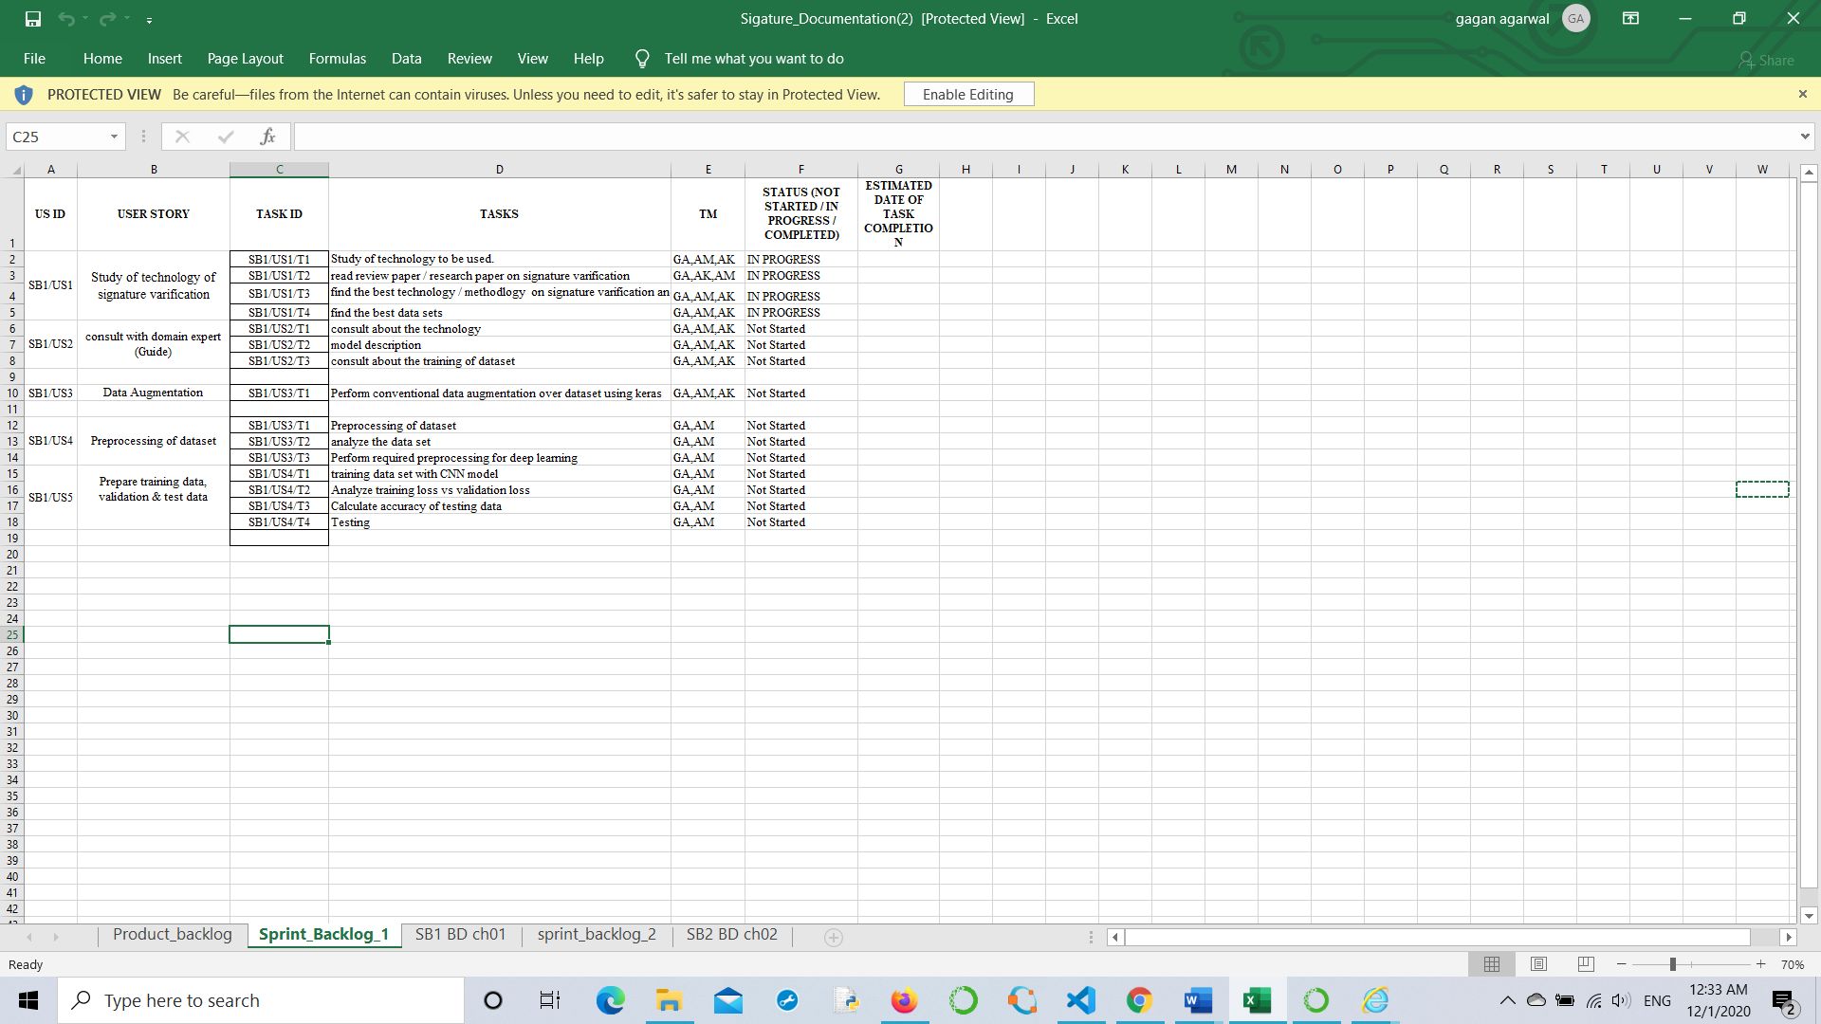

Fig2:-sprint backlog-1

Burn Down Chart-1

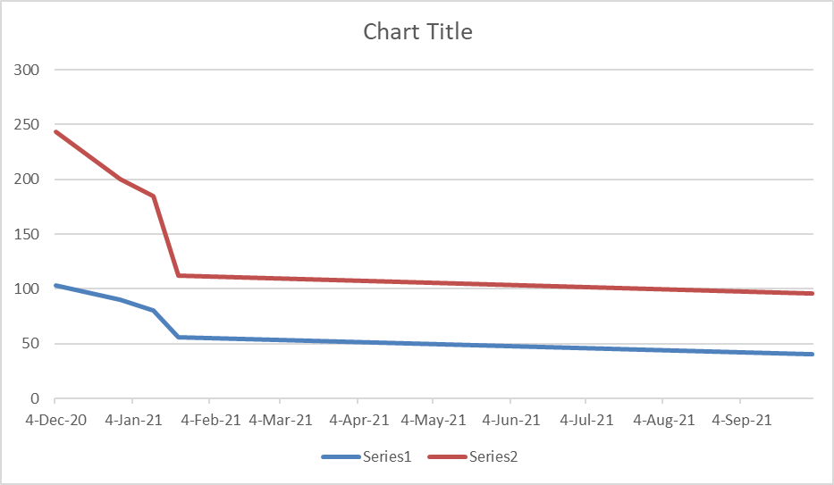

Fig3:- Burn Down Chart-1

- Sprint Backlog-2
In this phase we developed the application where user can write using the webcam.and the application.

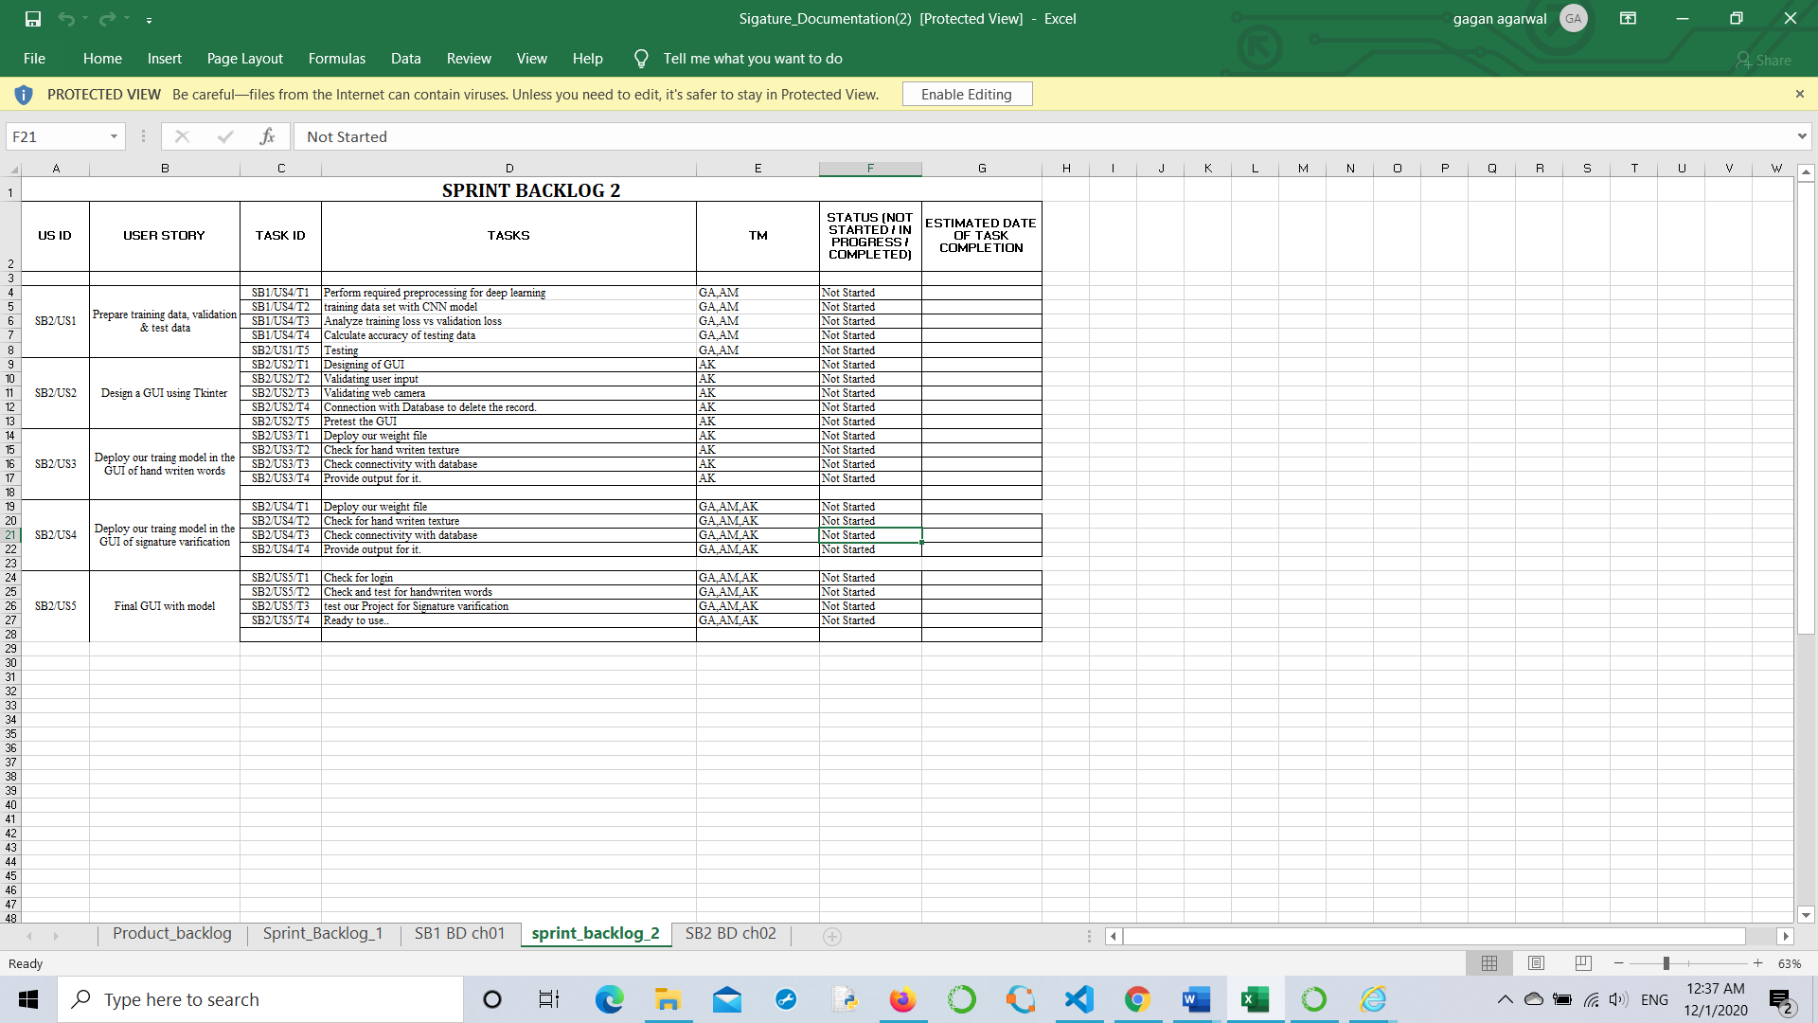

Fig4:-Sprint Backlog-2

Burn Down Chart-2
Spring Backlog 02 burn down chart
Date | Planned Total Task | Actual Uncompleted Task
14-Aug-20 | 103 | 140
3-Oct-20 | 90 | 110
28-Oct-20 | 80 | 105
11-Oct-20 | 56 | 56
22-Oct-20 | 40 | 56

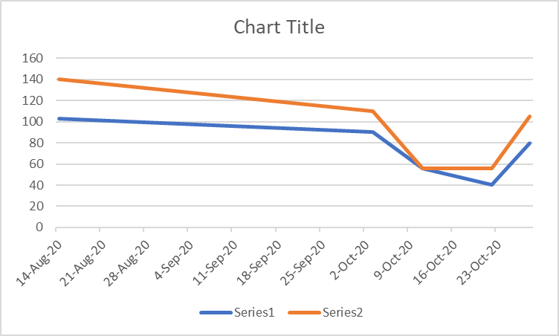

Fig5:- Burn Down Chart-2

CHAPTER 3

TECHNOLOGY APPLIED AND PROJECT MANAGEMENT
Project management :

Project management is the application of processes, methods, knowledge, skills and experience to achieve the project objectives. General. A project is a unique, transient endeavor, undertaken to achieve planned objectives, which could be defined in terms of outputs, outcomes or benefits.

Project management is the practise of initiating, planning, executing, controlling, and closing the work of a team to achieve specific goals and meet specific success criteria at the specified time. A project is a temporary endeavor designed to produce a unique product, service or result with a defined beginning and end undertaken to meet unique goals and objectives, typically to bring about beneficial change or added value. The temporary nature of projects stands in contrast with business as usual, which are repetitive, permanent, or semi-permanent functional activities to produce products or services. In practice, the management of such distinct production approaches requires the development of distinct technical skills and management strategies.

Project Estimation Techniques
We discussed various parameters involving project estimation such as size, effort, time and cost.Project manager can estimate the listed factors using two broadly recognized techniques

Decomposition Technique
This technique assumes the software as a product of various compositions.
There are two main models -
- Line of Code Estimation is done on behalf of number of line of codes in the software product.
- Function Points Estimation is done on behalf of number of function points in the software product.

Empirical Estimation Technique
This technique uses empirically derived formulae to make estimation.These formulae are based on LOC or FPs.
- Putnam Model
This model is made by Lawrence H. Putnam, which is based on Norden’s frequency distribution (Rayleigh curve). Putnam model maps time and efforts required with software size.
- COCOMO
COCOMO stands for COnstructiveCOstMOdel, developed by Barry W. Boehm. It divides the software product into three categories of software: organic, semi-detached and embedded.
PO and Their Relevance to project
PO1: Engineering knowledge:Apply the knowledge of mathematics, science, engineering fundamentals and an engineering specialization to the solution of complex engineering problems.
In this project creation process engineering knowledge of the software engineering and Electronics engineering have been applied. we have used software engineering , HTML,xml, java , android , java script , php , j2ee, data base , oracle , my sql , mango and other programming language and database to the project. We have applied all above engineering subjects in our projects.
PO2: Problem analysis:Identify, formulate, review research literature, and analyze complex engineering problems reaching substantiated conclusions using first principles of mathematics, natural sciences, and engineering sciences.

In our projects we have identified an problem , once verified by the client we have worked to identify the solution using all of our theoretical and practical knowledge.
PO3: Design/development of solutions: Design solutions for complex engineering problems and design system components or processes that meet the specified needs with appropriate consideration for the public health and safety, and the cultural, societal, and environmental considerations.

PO4: Conduct investigations of complex problems: Use research-based knowledge and research methods including design of experiments, analysis and interpretation of data, and synthesis of the information to provide valid conclusions.

PO5: Modern tool usage:Create, select, and apply appropriate techniques, resources, and modern engineering and IT tools including prediction and modeling to complex engineering activities with an understanding of the limitations.

In the project development we have applied Integrated Development Environment IDE for the rapid development of the code, used web server for the software development.

PO6: The engineer and society: Apply reasoning informed by the contextual knowledge to assess societal, health, safety, legal and cultural issues and the consequent responsibilities relevant to the professional engineering practice.
In 1961 , the Conference of Engineering Societies of Western Europe and the United States of America defined "professional engineer" as follows.
A professional engineer is competent by virtue of his/her fundamental education and training to apply the scientific method and outlook to the analysis and solution of engineering problems. He/she is able to assume personal responsibility for the development and application of engineering science and knowledge, notably in research, design, construction, manufacturing, superintending, managing and in the education of the engineer. His/her work is predominantly intellectual and varied and not of a routine mental or physical character. It requires the exercise of original thought and judgement and the ability to supervise the technical and administrative work of others. His/her education will have been such as to make him/her capable of closely and continuously following progress in his/her branch of engineering science by consulting newly published works on a worldwide basis, assimilating such information and applying it independently. He/she is thus placed in a position to make contributions to the development of engineering science or its applications. His/her education and training will have been such that he/she will have acquired a broad and general appreciation of the engineering sciences as well as thorough insight into the special features of his/her own branch. In due time he/she will be able to give authoritative technical advice and to assume responsibility for the direction of important tasks in his/her branch.

PO7: Environment and sustainability: Understand the impact of the professional engineering solutions in and environmental contexts, and demonstrate the knowledge of, and need for sustainable development.
Sustainability is the ability to continue a defined behavior indefinitely. Sometimes environmental, social and economic are termed to be the three pillars of sustainability.
PO8: Ethics: Apply ethical principles and commit to professional ethics and responsibilities and norms of the engineering practice
The ethics of engineers and the fundamental principles for Engineers are as follows.
Engineers uphold and advance the integrity, honor and dignity of the engineering profession by:
I. using their knowledge and skill for the enhancement of human welfare;
II.being honest and impartial, and servicing with fidelity the public, their employers and clients;
III. Striving to increase the competence and prestige of the engineering profession; and
IV. Supporting the professional and technical societies of their disciplines.
PO9. Individual and team work: Function effectively as an individual and as a member or leader in diverse teams, and in multidisciplinary settings.
To work successful in team a team member must have following capabilities.
1. The Ability to Listen
it is important to listen to one another's ideas. Too often in a business setting, you have a group of people simply waiting for their turn to speak, not paying one iota of attention to the persons on their left or right. So it is a good teamwork skill to have the ability to listen
2. Check Your Ego
This isn't saying abandon your ego all together, because that isn't healthy. But leaving your ego at the door temporarily is a very important team work skill. The reason this is so essential is because there is always someone better than you at something, no matter how brilliant you are.
3. Critique
By critique, I mean constructive criticism. Be able to give others constructive criticism and be able to listen to others critique your ideas and work. There shouldn't be any offense taken to constructive criticism. You all want to succeed, and this is a vital step in doing so.
4. Delegation
The mentality must be applied to teamwork. Delegate roles to those who do them best.
5. Show Respect
If you and another person happen to be paired up and can't stand each other, you can still put that aside for a couple of hours, treat each other civilly, and complete the tasks at hand. You may even overcome the dislike toward one another.
6. Be Helpful
This is simple.If one of your teammates does not understand an idea, discussion, or task that is being completed, take the necessary time to explain it to them and work with them. There are no weak links when everyone helps one another. Some take longer to learn than others, but that doesn't mean that they are of less intelligence. If in a meeting someone asks a question because they don't understand, don't frown at them. Just answer the questions patiently and concisely.
7. Question One Another
If someone brings up a topic of discussion and a solution to this topic, question them. Respectfully question, don't badger. Rather, ask them how it will work, why it will work over the long-run, and how everyone else can implement the idea.
8. Participation
Have the entire team encourage shy people to engage in the topics of discussion. Don't demand it, but make them realize that you really want to hear their ideas.
9. Rational Debate
Bad ideas are bad for teams. Spirited, friendly, rational debate is where facts come forward, ideas are born, and quality rises to the top.
10. Set The Right Environment
Try to make the space in which your team is assembled as comfortable, relaxing, and inviting as possible. You do not want your team to be tense and with frayed nerves.

PO 10: Communication:Communicate effectively on complex engineering activities with the engineering community and with society at large, such as, being able to comprehend and write effective reports and design documentation, make effective presentations, and give and receive clear instructions.
PO11: Project management and finance:Demonstrate knowledge and understanding of the engineering management principles and apply these to one’s own work, as a member and leader in a team, to manage projects and in multidisciplinary environments.
Project management is the application of processes, methods, knowledge, skills and experience to achieve the project objectives. In general project is a unique, transient endeavour, undertaken to achieve planned objectives, which could be defined in terms of outputs, outcomes or benefits.
PO12: Life-long learning: Recognize the need for and have the preparation and ability to engage in independent and lifelong learning in the broadest context of technological change.
Life Long Learning means is the provision or use of both formal and informal learning opportunities throughout people's lives in order to foster the continuous development and improvement of the knowledge and skills needed for employment and personal fulfillment

CHAPTER 4

PROJECT IMPLEMENTATION

- Sprint Backlog-1
Train and test split
import glob, os
# Current directory
current_dir = os.path.dirname(os.path.abspath(__file__))
print(current_dir)
current_dir = '/content/drive/My Drive/'
# Percentage of images to be used for the test set
percentage_test = 20;
# Create and/or truncate train.txt and test.txt
file_train = open('train.txt', 'w')
file_test = open('test.txt', 'w')
# Populate train.txt and test.txt
counter = 1
index_test = round(100 / percentage_test)
for pathAndFilename in glob.iglob(os.path.join(current_dir, "*.jpg")):
title, ext = os.path.splitext(os.path.basename(pathAndFilename))
if counter == index_test:
counter = 1
file_test.write(current_dir + "/" + title + '.jpg' + "\n")
else:
file_train.write(current_dir + "/" + title + '.jpg' + "\n")
counter = counter + 1

Configuration File:-
[net]
# Training
# batch=128
# subdivisions=1
# Testing
batch=1
subdivisions=1
height=227
width=227
channels=3
momentum=0.9
decay=0.0005
max_crop=256

learning_rate=0.01
policy=poly
power=4
max_batches=800000

angle=7
hue = .1
saturation=.75
exposure=.75
aspect=.75

[convolutional]
filters=96
size=11
stride=4
pad=0
activation=relu

[maxpool]
size=3
stride=2
padding=0

[convolutional]
filters=256
size=5
stride=1
pad=1
activation=relu

[maxpool]
size=3
stride=2
padding=0

[convolutional]
filters=384
size=3
stride=1
pad=1
activation=relu

[convolutional]
filters=384
size=3
stride=1
pad=1
activation=relu

[convolutional]
filters=256
size=3
stride=1
pad=1
activation=relu

[maxpool]
size=3
stride=2
padding=0

[connected]
output=4096
activation=relu

[dropout]
probability=.5

[connected]
output=4096
activation=relu

[dropout]
probability=.5

[connected]
output=1000
activation=linear

[softmax]
groups=1

Pen tracking: -
camera = cv2.VideoCapture(0)

while True:
(grabbed, frame) = camera.read()
frame = cv2.flip(frame,1)
hsv = cv2.cvtColor(frame, cv2.COLOR_BGR2HSV)
if not grabbed:
break
#frame = cv2.rectangle(frame, (40,1), (140,65), (122,122,122), -1)
blueMask = cv2.inRange(hsv, blueLower, blueUpper)
blueMask = cv2.erode(blueMask, kernel, iterations=2)
blueMask = cv2.morphologyEx(blueMask, cv2.MORPH_OPEN, kernel)
blueMask = cv2.dilate(blueMask, kernel, iterations=1)

(_, cnts, _) = cv2.findContours(blueMask.copy(), cv2.RETR_EXTERNAL,
cv2.CHAIN_APPROX_SIMPLE)
if len(cnts) > 0:
cnt = sorted(cnts, key = cv2.contourArea, reverse = True)[0]
((x, y), radius) = cv2.minEnclosingCircle(cnt)
cv2.circle(frame, (int(x), int(y)), int(radius), (0, 255, 255), 2)
M = cv2.moments(cnt)
center = (int(M['m10'] / M['m00']), int(M['m01'] / M['m00']))
if len(cnts) > 0:
cnt = sorted(cnts, key = cv2.contourArea, reverse = True)[0]
((x, y), radius) = cv2.minEnclosingCircle(cnt)
cv2.circle(frame, (int(x), int(y)), int(radius), (0, 255, 255), 2)
M = cv2.moments(cnt)
center = (int(M['m10'] / M['m00']), int(M['m01'] / M['m00']))
points = [bpoints, gpoints, rpoints, ypoints]
for i in range(len(points)):
for j in range(len(points[i])):
for k in range(1, len(points[i][j])):
if points[i][j][k - 1] is None or points[i][j][k] is None:
continue
cv2.line(frame, points[i][j][k - 1], points[i][j][k], colors[i], 2)

cv2.imshow("Tracking", frame)
if cv2.waitKey(1) & 0xFF == ord("q"):
break
# Cleanup code
camera.release()
cv2.destroyAllWindows()

CHAPTER 5

Results
We successfully developed the pen tracking.

ANNEXURES

References
- https://www.kaggle.com/landlord/handwriting-recognition?select=test_v2
- https://pjreddie.com/darknet/

